**7**

NUMĂRUL SI CIFRA

*1. COLOREAZĂ / ÎNCERCUIEŞTE CIFRA* ***7****.*

**7 0 6 7 3 9** **7 5 6 2 7 8 7 9**

7 1 0 7 1 4 7 9 6 7 4 6 8 7 5 6 7

*2. COMPLETEAZĂ ELEMENTELE MULŢIMILOR:*

**3**

**7**

**7**

**5**

**0**

**1**

**4**

**6**

**2**

*3. SCRIE CIFRA 7.*

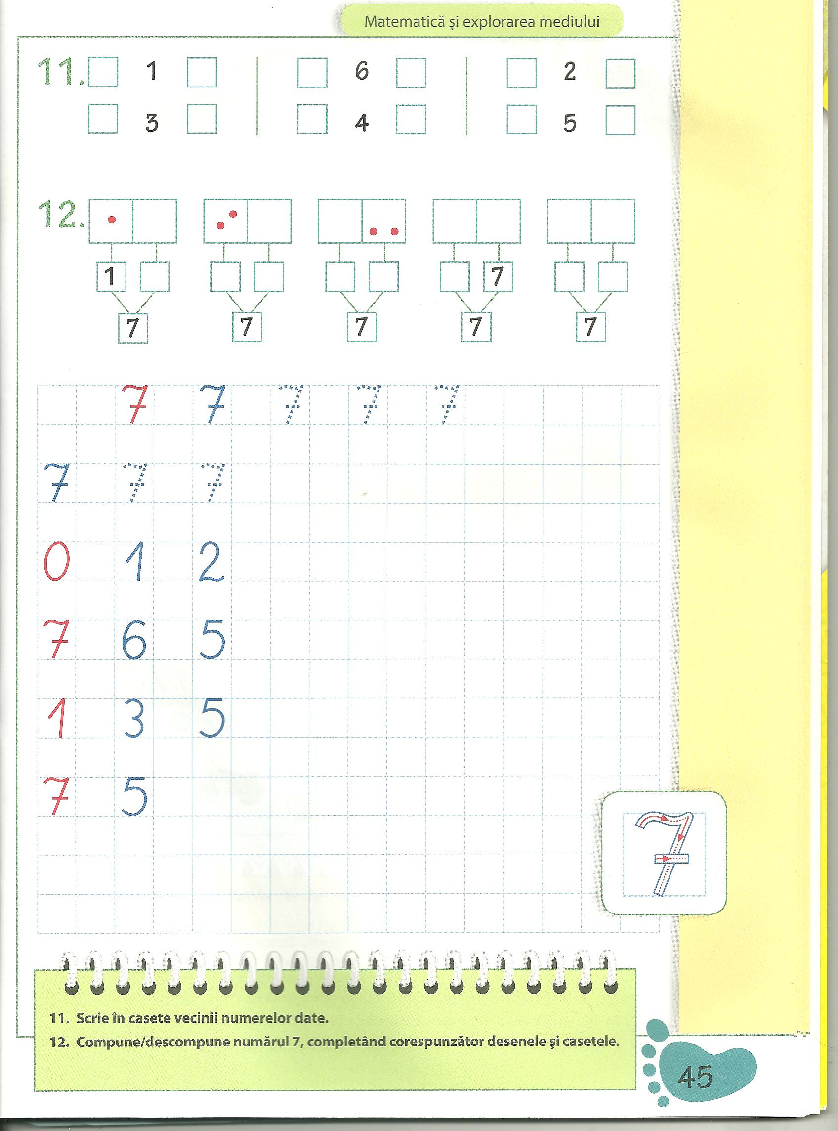

**

*4. SCRIE VECINII NUMERELOR:*

**4**

**5**

**3**

**7**



**6**

5

2

4

*5. DESCOMPUNE NUMĂRUL 7.*

7 7 7 7 7

7 7 7 6 6

*6. SCRIE NUMERELE ÎNVĂŢATE.*

|  |  |  |  |  |  |  |  |  |  |  |  |  |  |  |  |  |  |  |  |  |  |  |  |  |  |  |  |  |  |
| --- | --- | --- | --- | --- | --- | --- | --- | --- | --- | --- | --- | --- | --- | --- | --- | --- | --- | --- | --- | --- | --- | --- | --- | --- | --- | --- | --- | --- | --- |
|  |  |  |  |  |  |  |  |  |  |  |  |  |  |  |  |  |  |  |  |  |  |  |  |  |  |  |  |  |  |
|  |  |  |  |  |  |  |  |  |  |  |  |  |  |  |  |  |  |  |  |  |  |  |  |  |  |  |  |  |  |
|  |  |  |  |  |  |  |  |  |  |  |  |  |  |  |  |  |  |  |  |  |  |  |  |  |  |  |  |  |  |
|  |  |  |  |  |  |  |  |  |  |  |  |  |  |  |  |  |  |  |  |  |  |  |  |  |  |  |  |  |  |

*7. COLOREAZĂ CIFRELE.*

    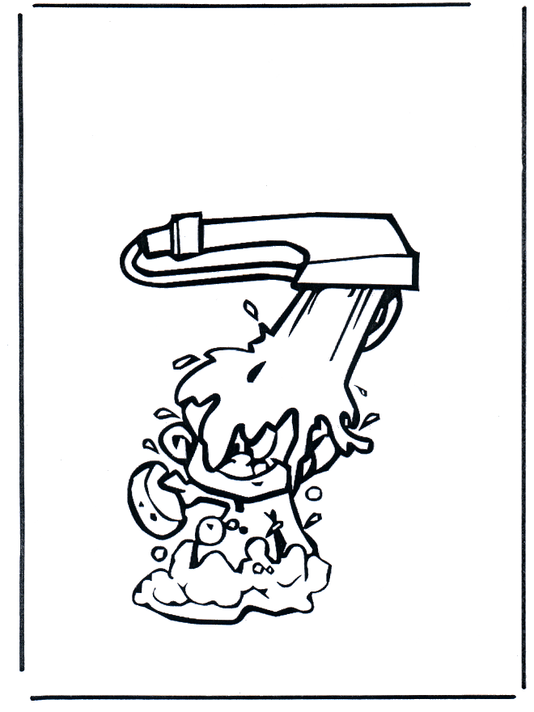

*8. COLOREAZĂ NUMĂRUL MAI MARE DIN FIECARE PERECHE .*

**6**

**7**

**3**

**4**

**1**

**7**

**2**

**6**

**4**

**7**

**3**

**7**

*9. COLOREAZĂ NUMĂRUL MAI MIC DIN FIECARE PERECHE .*

**0**

**7**

**6**

**1**

**6**

**2**

**2**

**7**

**7**

**5**

**7**

**3**

*10. COLOREAZĂ .*

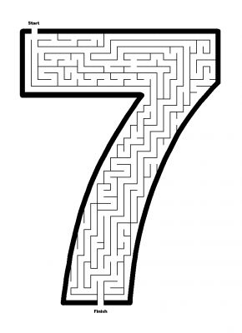 1-ALBASTRU 2- ROZ 3-PORTOCALIU

 4-ROŞU 5-VERDE 6-GALBEN 7-MOV

